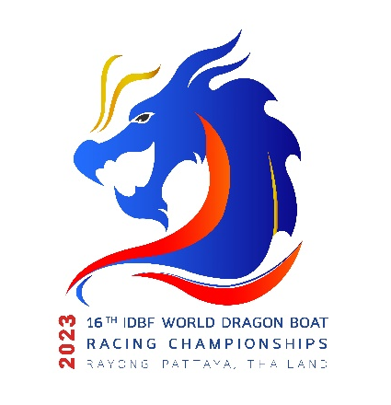
Rayong – Pattaya, Thailand | August 7 – 13, 2023

Hotel Reservation
National Federation:…………………………………………………………………………………………………………………………………………………………….…….
Team Name:…………………………………………………………………………………………………………………………………………………………….………………… Arrival Date:……………………………………………………………………………..….. Flight No.…………………………..…………………………………………….…
Departure Date:…………………………………………………………………………… Flight No.…………………………..………….……………………….…………..
Total No. of Persons:………………………………..…………………………….…… Male:……………………..…….…… Female:………………………….…….
No. of Hotel Rooms Required:………………………………………………………………………………………………………………………….………………………
Accommodation Package Fee
- Kantary Hotel Ban Chang, Rayong
Check in Date | Check out Date | Room type | Rate (USD) | No. of Nights | No. of Rooms | Sub-Total (USD)
 |  | Twin | 75
 |  | Single | 100

- D Varee jomtien Beach Pattaya, Pattaya
Check in Date | Check out Date | Room type | Rate (USD) | No. of Nights | No. of Rooms | Sub-Total (USD)
 |  | Twin | 75
 |  | Single | 100

- Ambassador City Jomtien, Pattaya
Check in Date | Check out Date | Room type | Rate (USD) | No. of Nights | No. of Rooms | Sub-Total (USD)
 |  | Twin | 85
 |  | Single | 110

- Grand Jomtien Palace Hotel, Pattaya
Check in Date | Check out Date | Room type | Rate (USD) | No. of Nights | No. of Rooms | Sub-Total (USD)
 |  | Twin | 65
 |  | Single | 90

- Star Convention Hotel, Rayong
Check in Date | Check out Date | Room type | Rate (USD) | No. of Nights | No. of Rooms | Sub-Total (USD)
 |  | Twin | 70
 |  | Single | 95

- Play Phala Beach, Rayong
Check in Date | Check out Date | Room type | Rate (USD) | No. of Nights | No. of Rooms | Sub-Total (USD)
 |  | Twin | 70
 |  | Single | 95

- Golden City Rayong, Rayong
Check in Date | Check out Date | Room type | Rate (USD) | No. of Nights | No. of Rooms | Sub-Total (USD)
 |  | Twin | 70
 |  | Single | 95

- Kantary Bay, Rayong
Check in Date | Check out Date | Room type | Rate (USD) | No. of Nights | No. of Rooms | Sub-Total (USD)
 |  | Twin | 80
 |  | Single | 105

- Kameo Grand, Rayong
Check in Date | Check out Date | Room type | Rate (USD) | No. of Nights | No. of Rooms | Sub-Total (USD)
 |  | Twin | 80
 |  | Single | 105

- Classic Kameo, Rayong
Check in Date | Check out Date | Room type | Rate (USD) | No. of Nights | No. of Rooms | Sub-Total (USD)
 |  | Twin | 80
 |  | Single | 105

- Jomtien Palm Beach Hotel & Resort, Pattaya
Check in Date | Check out Date | Room type | Rate (USD) | No. of Nights | No. of Rooms | Sub-Total (USD)
 |  | Twin | 80
 |  | Single | 105

- Go hotel Ban Chang, Rayong
Check in Date | Check out Date | Room type | Rate (USD) | No. of Nights | No. of Rooms | Sub-Total (USD)
 |  | Twin | 65
 |  | Single | 90

- Welcome Jomtien Beach Hotel, Pattaya
Check in Date | Check out Date | Room type | Rate (USD) | No. of Nights | No. of Rooms | Sub-Total (USD)
 |  | Twin | 65
 |  | Single | 90

- Serene Phala Resort and Restaurant, Rayong
Check in Date | Check out Date | Room type | Rate (USD) | No. of Nights | No. of Rooms | Sub-Total (USD)
 |  | Twin | 85
 |  | Single | 110
Total Accommodation Fee (USD):………………………………………………………………………………………………
*All Booking subject to first come first serve basis with availability of the room
(Bank Details for Payments would be given later)
Signature & Stamp of Federation _______________________________________________________________
Name and position of authorised signatory ______________________________________________________
Contact telephone no.: _________________________ E-mail: ______________________________________

